This document is for the documentation and explanation deliverable of our activity 1 in ELEC-3 subject course. It will explain parts of the code and explain how and why it is implemented.

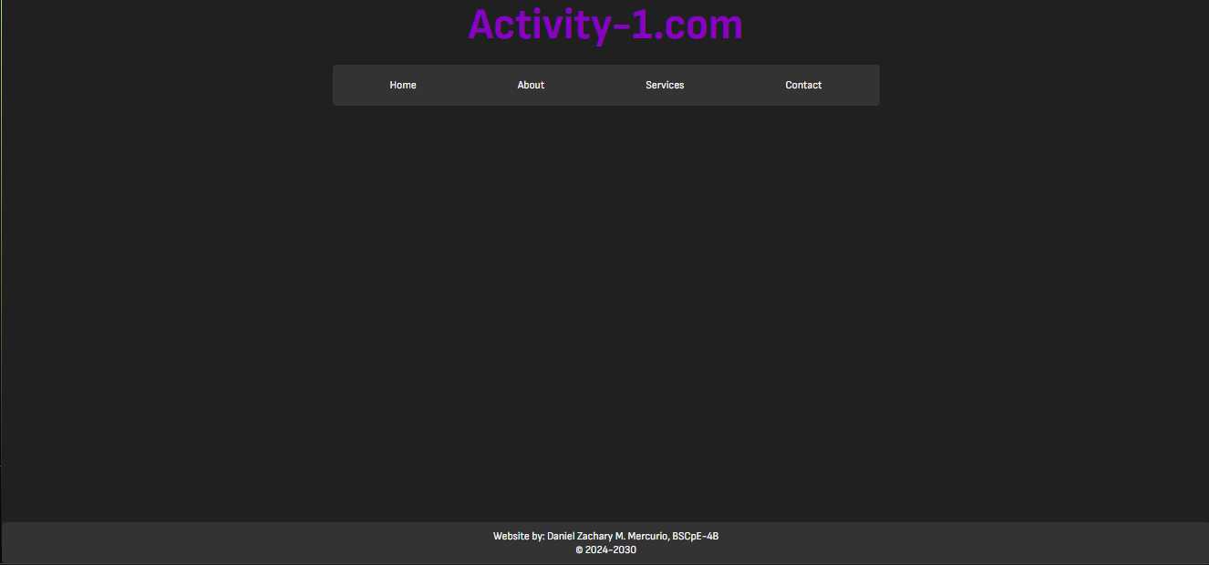 | This is the main UI of the website
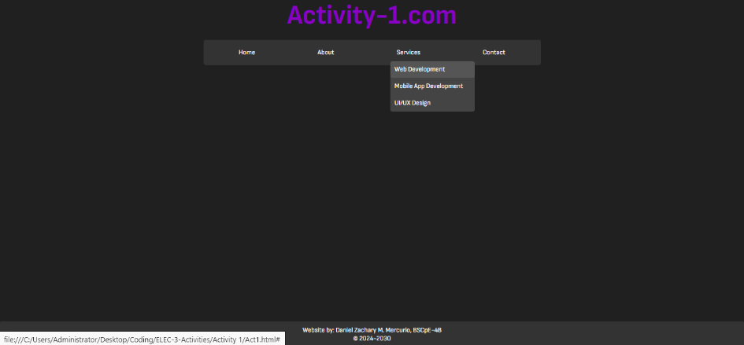 | This is a screenshot of the function of a dropdown in the services tab of the menu
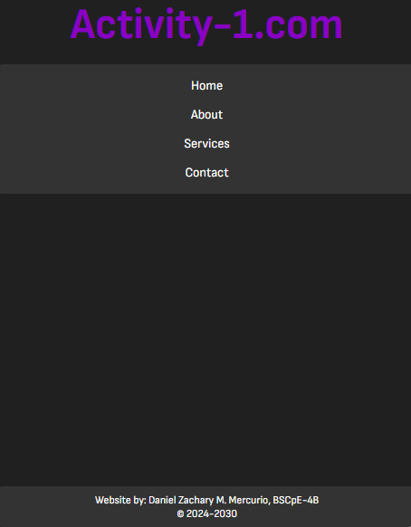  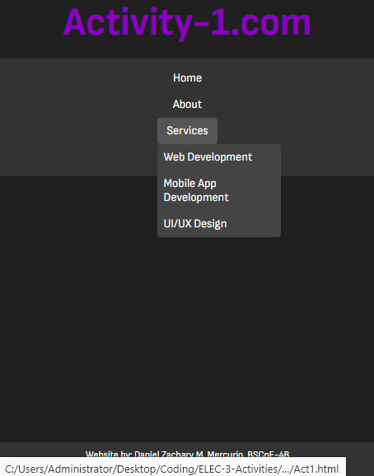 | Mobile view of the website
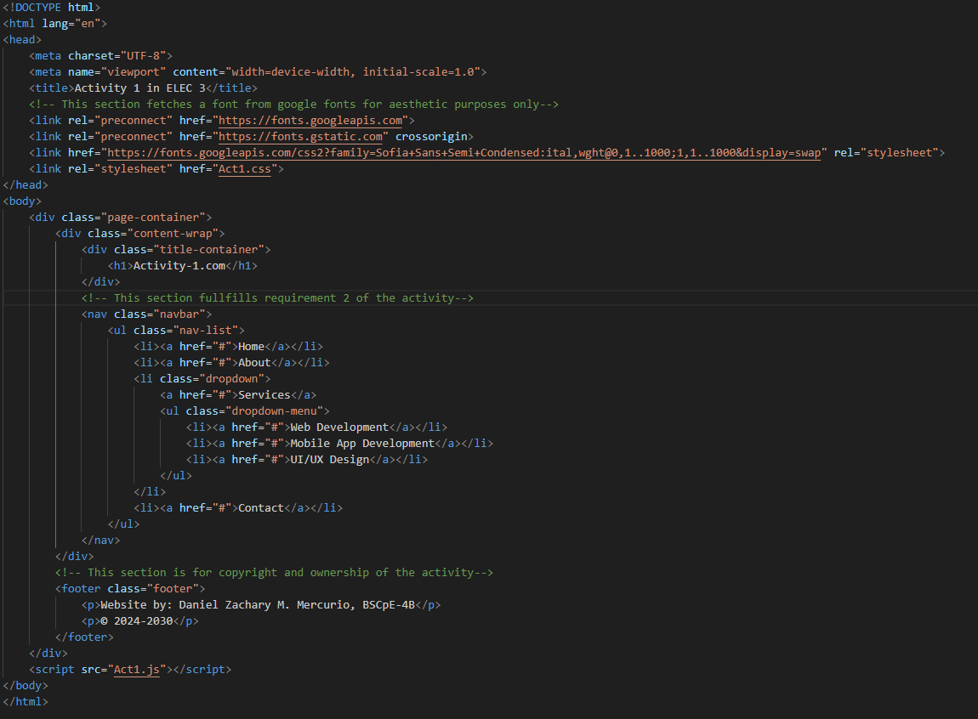
This is the HTML code of the website; it is very basic right now since the activity does not require many features in the website. I’ve taken the liberty in adding a title for the webpage and a footer for aesthetic purposes and as a proof of ownership of the output. I’ve also used a google font API to have a customized font imported into my CSS file. The navbar is just a list of links with no html to reference as of now since it is not yet required, and the menu of the services are just sub-list under the services itself.

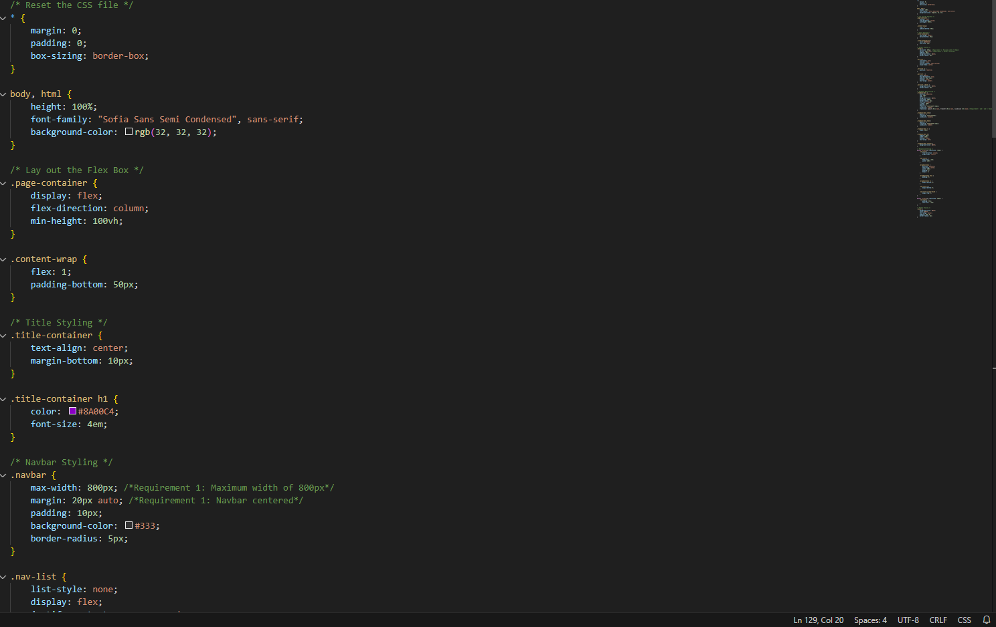 |  | The CSS file is pretty extensive but very self-explanatory in it of itself, thus some of it parts does not need any explanations.  The navbar is responsible for the styling of the navigation bar of the menu. It fulfills the 1st requirement of the activity (centered and 800px max)
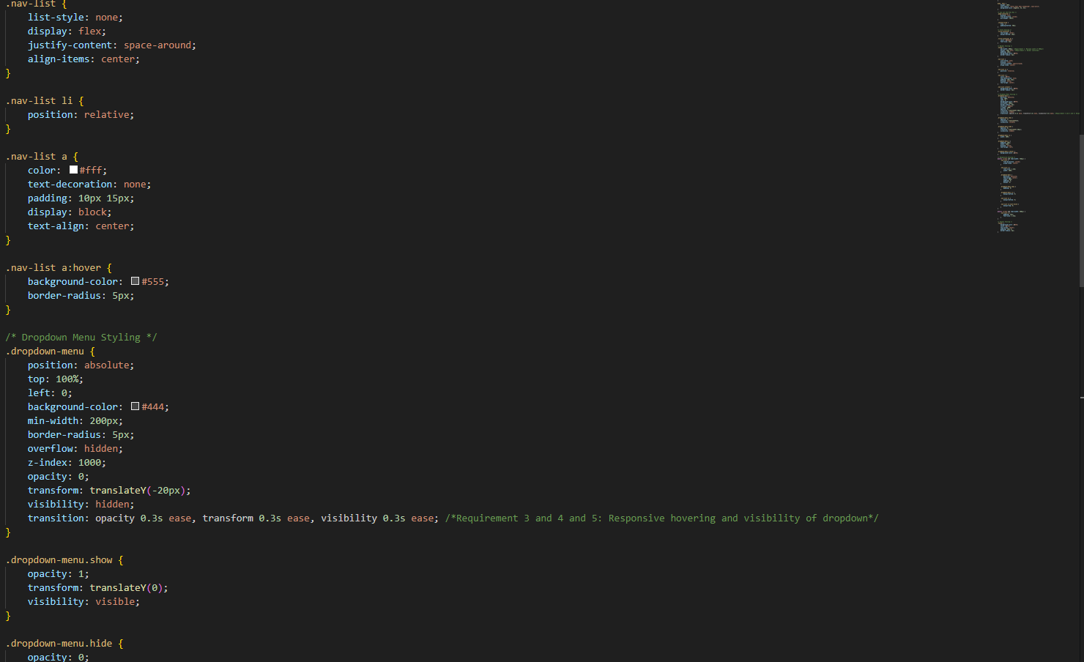 |  | This section is mainly focused on styling the nav list. As well as the styling of the dropdown menu of the services. The dropdown styling utilizes a transition to ease in and ease out the appearance of the dropdown menu, fulfilling requirement 3, 4 and 5 of the activity.
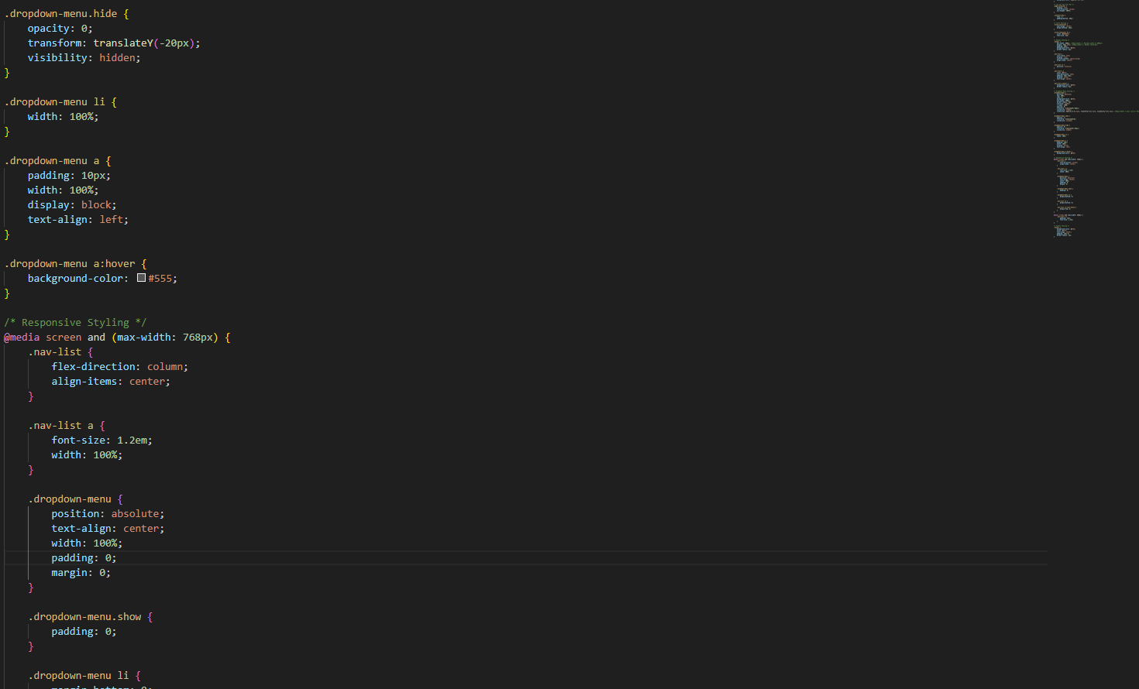 |  | This section of the .css is fir the function of the hiding and showing of the dropdown menu as well as its other stylings. The responsive styling on the bottom is for the case of when the website is viewed on a mobile device of a smaller UI; it will still be aesthetically acceptable.
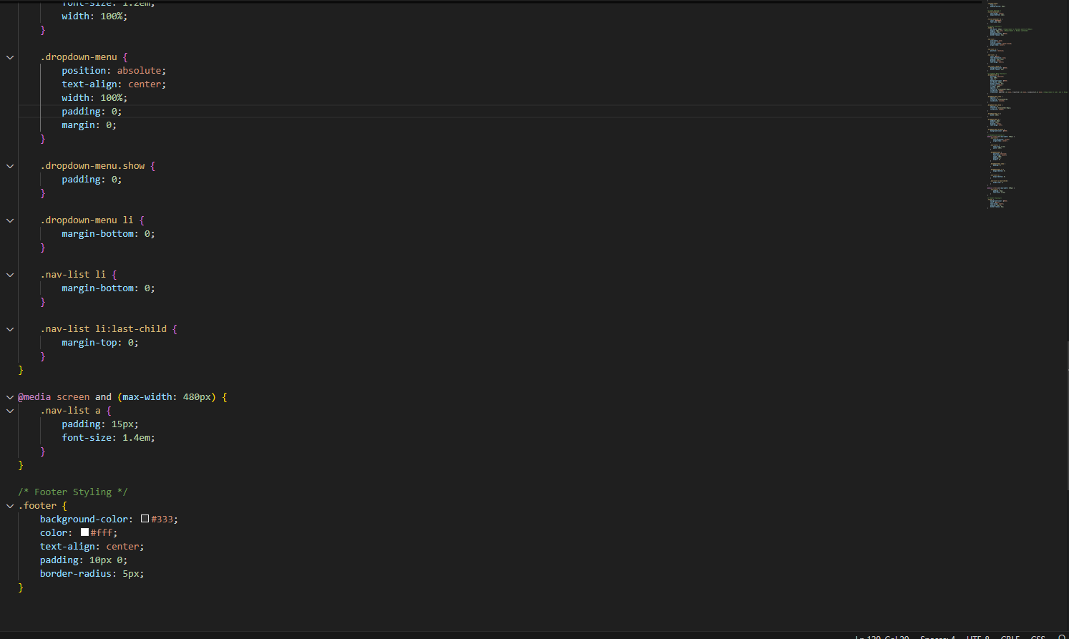 |  | And finally, we have the styling of the footer of the website as well as the other styling of the dropdown menu.
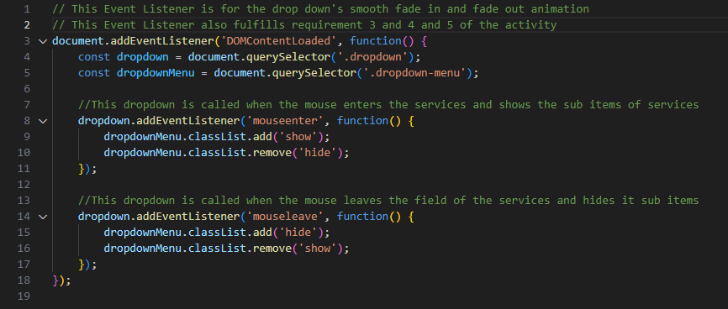 |  | This is the .js of the webpage, it uses an event listener to the mouse to show and hide the dropdown menu when the mouse enters and leaves the area of the services link of the website.

For a comprehensive compilation of my past, present, and future activities in our technical elective 3 course, all of them are available in this GitHub repository:
https://github.com/Getting-into-coding/ELEC-3-Activities

